ELECTRICITY LABELING 2024

Mix of the producer: ČEZ, a. s.

Coal |  | 27.71%
Nuclear |  | 64.26%
Gas |  | 3.60%
Renewables |  | 4.43%
o/w | water | 3.38%
 | wind | 0.02%
 | biomass | 0.86%
 | solar | 0.17%
 | other | 0.00%
Total |  | 100.00%

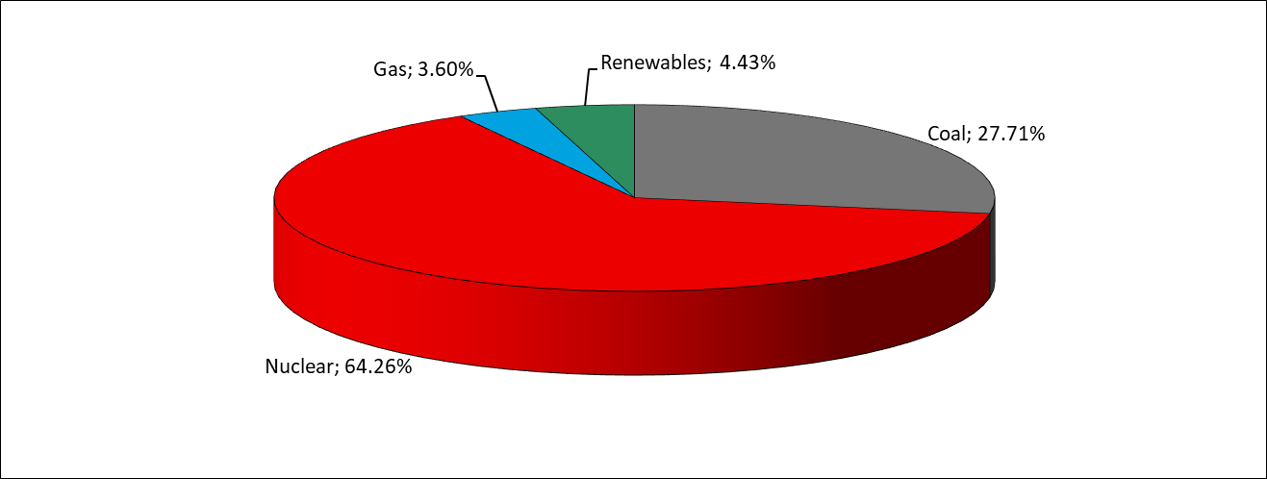

Emissions (in tons)
CO₂ | 11,834,359
NO_{x} | 8,692
SO_{x} | 3,486
PM | 257

Burnt nuclear fuel (in tons)
Production | 89
Delivered to RAWRA | 0

Radioactive waste (in tons)
Produced and delivered to RAWRA | 384

RAWRA - Radioactive Waste Repository Authority

ELECTRICITY LABELING 2024

Mix of the supplier: ČEZ Prodej, a.s., and ČEZ ESCO, a.s.

Renewables |  | 16.87%
o/w: | solar | 5.56%
 | wind | 1.11%
 | hydro | 2.05%
 | geothermal | 0.00%
 | biomass | 8.14%
 | other | 0.00%
Fossil |  | 45.04%
o/w: | lignite and hard coal | 39.62%
 | natural gas | 5.15%
 | oil and petroleum products | 0.11%
 | secondary sources | 0.16%
Nuclear |  | 38.09%

